
Company
Logotype

Cone Beam Computed Tomography- Report



Porur Dental X-rays & CBCT

Patient Name : Mrs. Srimathi | Date of Report : 20.06.2025
Age/ Gender : 45 years/ Female | Region of Interest : CBCT Sectional Mandible
Referring doctor: Dr. Selva Ganesh | Indication : Periapical pathology
Clinical Notes: Nil
PATIENT INFORMATION

CBCT Sectional Mandible provided
CBCT – IMAGE DETAILS

RADIOGRAPHIC INTERPRETATION

- In relation to the 36 presence of hyperdense restorative material involving the pulp canal upto the apical aspect of the mesial root canals (buccal and lingual) and upto the middle third of the distal root canal (buccal and lingual) is evident.
- In relation to the 37 presence of hyperdense restorative material involving the mesio-coronal portion is evident. Additionally, there is hypodense line differentiating the restorative material and the crown, and the tooth below the restorative material is present with mild hypodensity.
- The alveolar bone of the mandibular ridge is present with normal trabecular pattern.

RADIOGRAPHIC IMPRESSION

- Root Canal treated tooth (partially) with crown in relation to 36.
- Restored: 37 with secondary caries.


Kindly correlate with clinical and histopathological features

IMAGES FOR REFERENCE

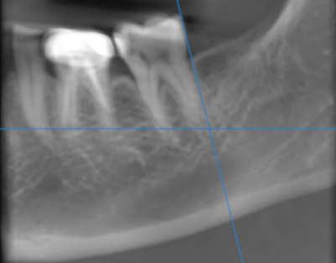
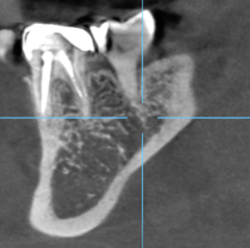
RECONSTRUCTED PANORAMIC VIEW
Sagittal view of 37 region mentioning the restoration

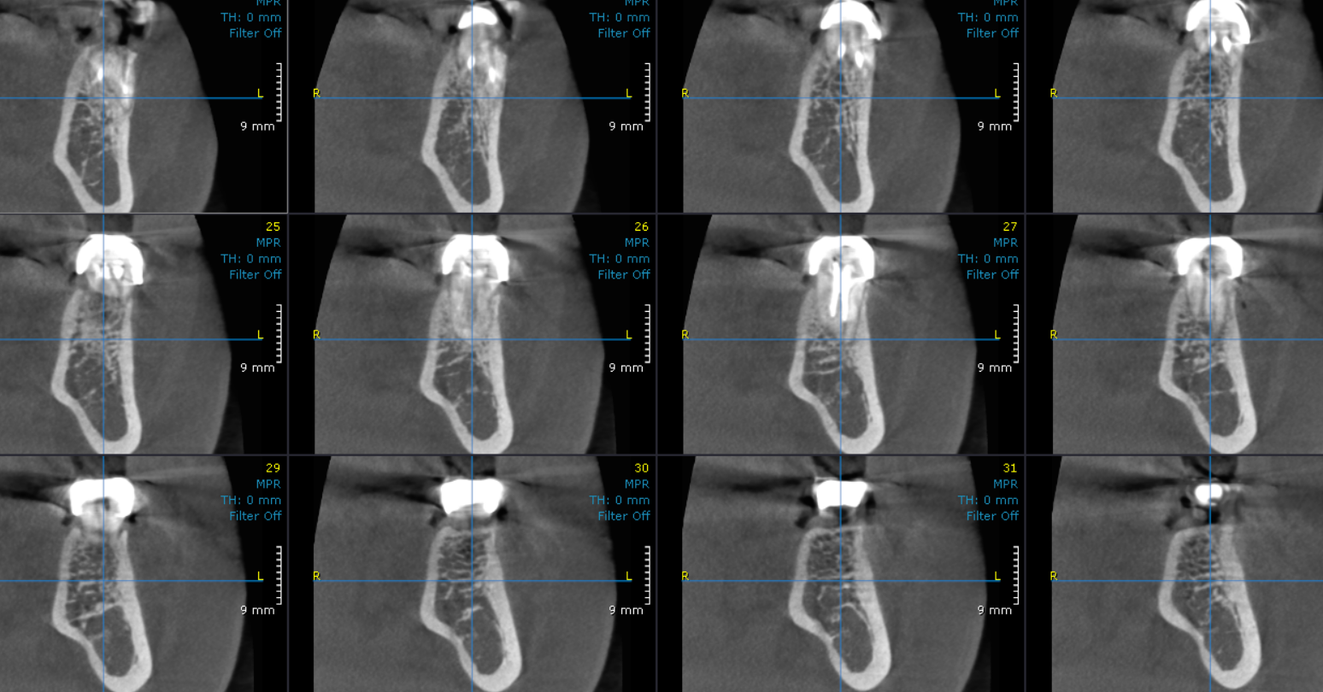
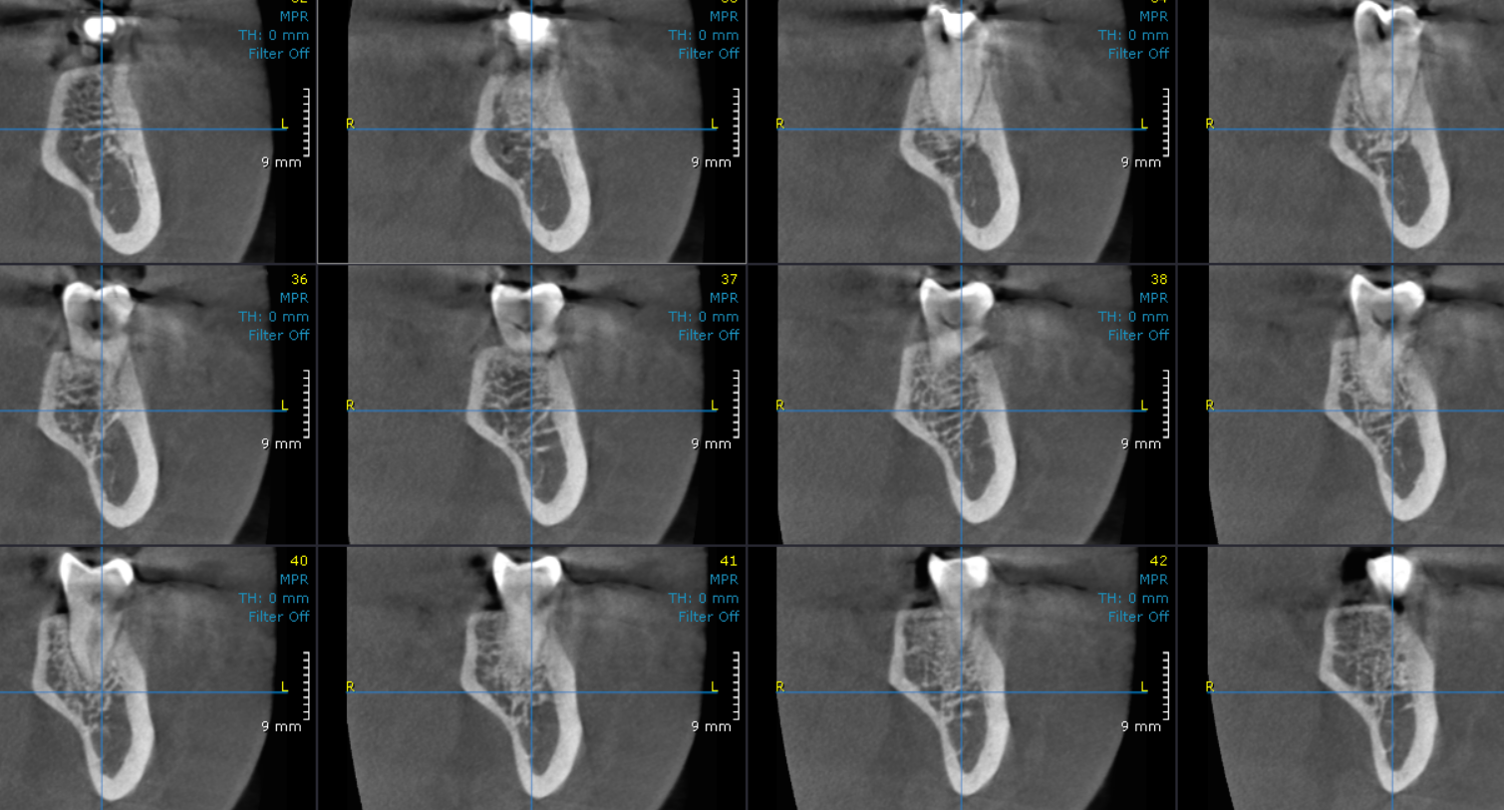
36 region
37 region
CROSS SECTIONAL IMAGES FOR REFERENCE

3-DIMENSIONAL VIEW

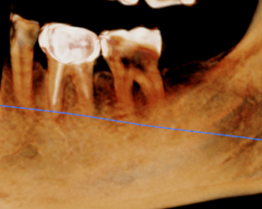

**** End of report ****

